 | 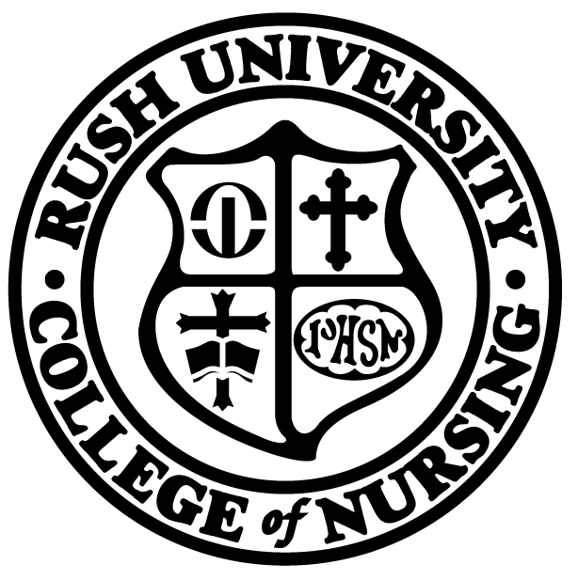 | Rush University, College of Nursing
 |  | PhD Presentation Reservation Form
 | Date:
 | Student Name:
 |  |  | (Print name as you would like it to appear in the public announcement. Include degrees and titles)
Contact Information:
 |  |  |  | Daytime Phone |  |  |  | Alternate Phone
 | Title:

Type of Presentation
ACRP Comprehensive Exam/Meeting Dissertation Proposal Dissertation Defense

Date of Presentation:
1st Choice: date time 2nd Choice: date time

A laptop and projector will be arranged. List any other equipment needed:

Return completed form to: Rush University College of Nursing
Office of Academic Affairs – PhD Program Assistant
600 S. Paulina Street, Suite 1080
Chicago, IL 60612
Fax: 312-942-3043

Note: This form must be submitted at least two weeks prior to proposed presentation date.

