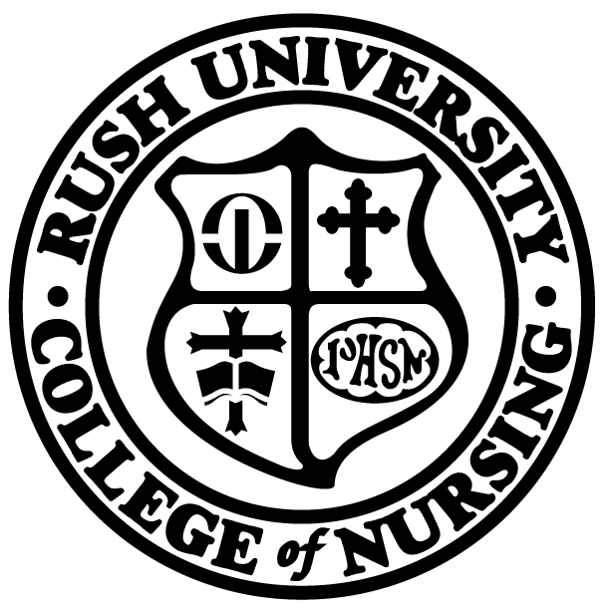 | Rush University, College of Nursing
 | Application for Transfer Form

Policy:
- The application for transfer procedure must be completed when an enrolled student wishes to change their program concentration and/or degree. The transfer must be approved; there is no guarantee of movement from one program to another.
- Program Director in the proposed concentration/degree determines the necessary requirements for the review process.
- The Registrar processes changes at the end of each term.
- Change is official as of the start of the new term if student accepted into the proposed major/concentration.
- If permission is granted and as space permits, students will only be allowed to transfer to an already matriculating cohort of students.

Procedure:
Student | - Meets with current advisor to discuss change.
Student and Advisor | - Completes Section 1 of the Application for Transfer form.  - Submits form to the Program Coordinator of the proposed concentration/degree.
Program Coordinator  Program Director of proposed program  Program Coordinator | - Sends Application for Transfer form to proposed Program Director.  - Determines requirements in Section 2 for consideration of transfer and when official review will occur.  - Notifies student of required documents and deadline date for submission as determined by Program Director of proposed concentration/degree.
Student | - Submits the required documents to the Program Coordinator of the proposed concentration/degree by date specified.
Program Coordinator | - Prepares a transfer file which includes designated required documents.  - Gives transfer file and Application for Transfer form to the proposed Program Director and a copy of Transfer form to the Admissions Specialist.  - Contacts student to schedule an interview with proposed Program Director, if required.
Program Director of proposed program | - Determines and notifies student whether transfer is approved or denied. Completes Section 3 of the form.  - Assigns advisor if the student is accepted for transfer.  - Signs the Application for Transfer form and gives the form and transfer file to the Program Coordinator.

Program Coordinator | - If the student is accepted:  - Submits original Application for Transfer form and transfer file to the Office of the Registrar.  - Distributes copies of the transfer form to those listed on distribution list.  - Places a copy of the Application for Transfer form and the transfer file in the new advisor’s mailbox.  - If the student is denied:  - Submit original Application for Transfer form and transfer file to the Office of the Registrar.

Rush University, College of Nursing
Application for Transfer Form
Section 1

Student ID: |  |  | Initiation Date:
Last Name: |  |  | First Name:
Phone (Home): |  |  | Phone (Other):
Current Degree Exit: |  | MSN DNP PhD Post-Grad. Certificate
Proposed Degree Exit: |  | MSN DNP PhD Post-Grad. Certificate

Current Area of Concentration/Degree Exit:
Proposed Area of Concentration/Degree Exit:
Current Advisor Name |  | Signature |  | Date
Current Program Director Name |  | Signature |  | Date

Additional Comments:

Section 2

Program Director of proposed area of concentration*:

REQUIREMENTS (as determined by Program Director of program student is applying to).
- Current clinical recommendations ________ (fill in the # of recommendations required)*
- A statement explaining the reason(s) for the requested change
- Completion of appropriate Degree essay from application ( MSN, DNP, PhD, post-graduate certificate)*
- Updated CV/Resume*
- Current Rush transcript (unofficial copy may be obtained through RU Connected portal)*
- Interview*
- Graduate Record Examination scores*
- Current RN license*
- Current ACLS card*
- Current CPR (BLS) card*
- Current PALS card*

- Other, as indicated. ______________________________________________________________

Deadline date for submission of required documents: _____________________________________________

Proposed term of entry: _____________________________________________________________________

*These items are specifically required for the Nurse Anesthesia Program.

Section 3

Decision to transfer to new program: Admit Deny

New Area of Concentration/Degree Exit:
New Program Director |  | Signature |  |  | Date

Effective Start Term: | Spring Summer Fall Year:

Submit completed and signed form to:  Rush University College of Nursing  Program Coordinator  Office of Academic Affairs  600 S. Paulina Street, Suite 1080  Chicago, IL 60612 | Distribution: Registrar’s Office  cc: Student File  Current Advisor  New Advisor  Previous Program Director  New Program Director  Admissions Specialist

