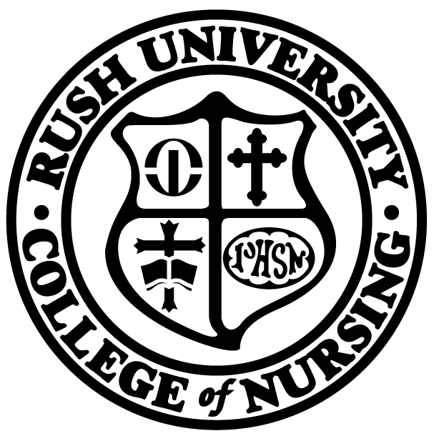 | Rush University, College of Nursing
Operational Guidelines for Academic Improvement
Success Plan

The purpose of the Success Plan is to document the processes used to address concerns that could lead to unsuccessful completion of a course (lecture or clinical).

The Success Form is to be used at all levels (prelicensure to PhD) and in all programs. The Success Form must be initiated as soon as the course director and/or clinical instructor recognizes that a student’s performance may jeopardize the successful completion of a course or progression in a program of study. The form can be initiated at any time during a quarter. It is suggested that it be done as early as possible, so the student has time to implement the plan of action to improve the situation.

Guidelines:
- Upon identifying a student who is having or may have difficulty successfully completing a course or clinical, the course director/instructor meets with the student and devises a plan to address the area(s) of concern.
- The course director/instructor then completes the Success Form Parts I and II.
- The course director/instructor provides the student with a copy of the Academic Improvement Form and forwards the original to the appropriate Program Director in the Office of Academic Affairs, indicating at that time whether assistance is needed with securing university support for tutoring or other student needs.
- The Program Director ensures a copy of the form is:
  - placed in the student’s file,
  - forwarded to the student’s academic advisor, and
  - retained on record in the Office of Academic Affairs for purposes of monitoring student progress.
- The course director/instructor updates the Program Director and the student’s academic advisor on the student’s progress as appropriate.

Revised 08/18
Rush University, College of Nursing
Success Form

Part I (to be completed by Course Director or Clinical Instructor)
Date:

To: | ❑ Director, Generalist Education   Director, PhD Program   Director, Specialty Programs and DNP
From:
 | (course director or clinical instructor)
Re:
 | (student name)
Course:
 | (course prefix and number)
A student requires a formal academic improvement plan when one or more course objectives are not being met. These behaviors, if not addressed, put the student at risk for receiving a non-passing final grade in this course. This is a notification that the above student is not meeting the passing standard set for this course.

Please include a brief description of the area of concern:
Theory Grade:

Clinical Grade: |  |  | (Please attach a copy of the student’s clinical evaluation and/or clinical contact)
Professional Behavior (includes plagiarism):
Comments:

Part II (to be completed by Academic Facilitator)
Plan of Action:

Intended Action Items (specify dates):
 | Will meet with Course Director and/or Clinical Instructor
 | Will seek tutorial services (specify if assistance is needed in locating tutors):
 | Refer to Program Director (if indicated)
Student’s signature: |  |  |  | Date:
Revised 08/18

